|  |  |  |  |  |  |  |  |  |
| --- | --- | --- | --- | --- | --- | --- | --- | --- |
| **MAD Project Evaluation 1 – Regular Intake 2020** | | | | | | | | |
| **Group Name:** | iv Spartans | | **Group ID:** | G9.1 | **Batch:** | 09 | | |
| Student ID | Student Name | Consistency (Out of 2) | Appropriateness and Professionalism (Out of 3) | Usage of resource manager (Out of 4) | Out of box design ideas (Out of 3) | Report (Out of 8) | Total (Out of 20) | Comments |
| IT19051208 | S.A.H.A. Sakalasooriya |  |  |  |  |  |  |  |
| IT19011462 | T.M.K.L. Thennakoon |  |  |  |  |  |  |
| IT19021058 | E.M.A.P. De Seram |  |  |  |  |  |  |
| IT19044446 | R.K. Rajapaksha |  |  |  |  |  |  |
|  |  |  |  |  |  |  |  |

Git Repository Link: <https://github.com/akalankasakalasooriya/M-A-D-project>

----------------------------------------------------------------------------------------------------------For Evaluators use only---------------------------------------------------------------------------------------------

Evaluator’s name:

Others:

**Mobile Application Developed to Empower Freelancers**

“Sewaseven” is a mobile application developed for service providers to provide their work through an online platform. Service providers and the customers can log in to this application using their own login credentials. Service providers can publish their services, announcements, and provide service details at the FAQ session whereas, the customers can get services, give ratings, and provide feedback to the service providers.

This is a user-friendly application that can be used anywhere at any time using a mobile phone. This would be beneficial for the customers to find out their service providers easily and quickly.

For example, if a customer needs to repair his/her mobile phone they can find out a service provider according to their preferred budget and contact them. A customer can also check the ratings of service providers.

**Design principles**

Our “sewa seven” app inspired by Google’s “Material design language”. Additionally, we use colorful icons to get more attractive interface. Our color combinations are also part of Google’s “Material design language”. All the team members used *‘colors.xml’* resource commonly.

<**color name="btn_background"**>#4285F4</**color**>  
<**color name="btn_text"**>#ffffff</**color**>  
<**color name="btn_sign_in"**>#DB4437</**color**>

**IT19051208 - Rating and review management and user account control (sign up, sign in, log out)**

***Giving a rating and review to a Service by User***

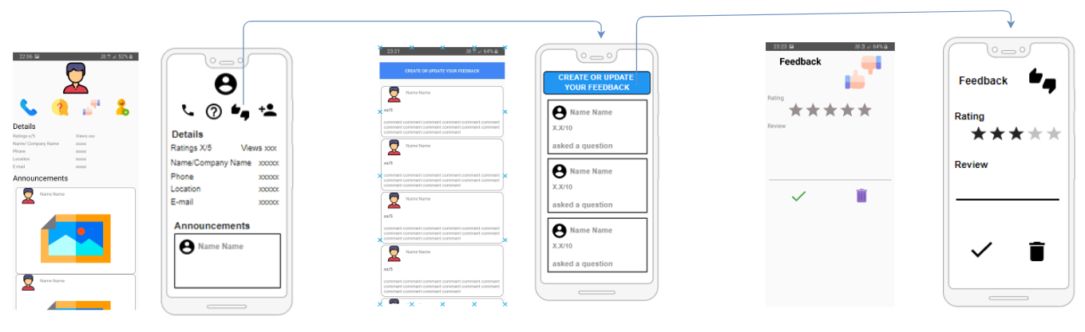

*\*note- if user had already submitted rating and review it will automatically appear on the feedback page \**

*\*note- if user wants to delete his rating, user should click on ‘bin’ icon\**

*\*note- if user wants to update his rating, user should click on ‘right’ icon\**

***check his/her service’s ratings and reviews***

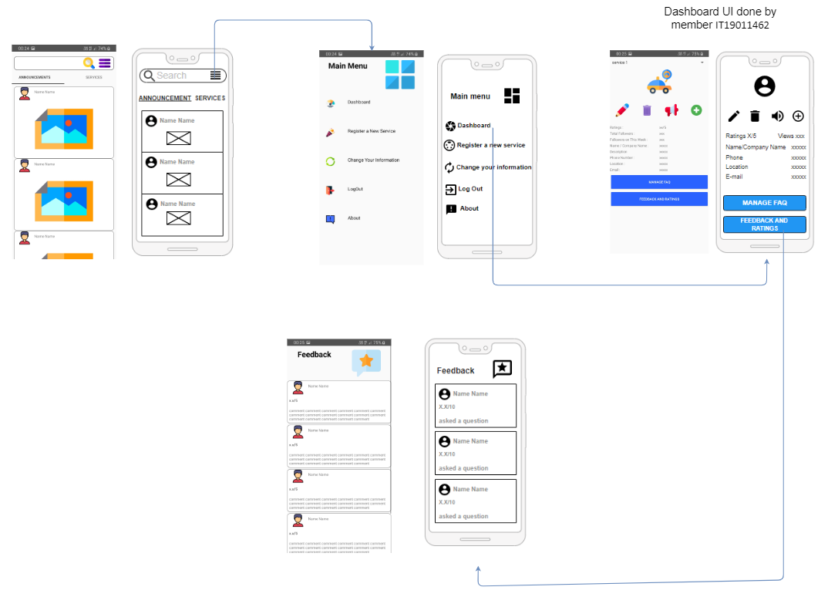

***User account control (sign in and sign up)***

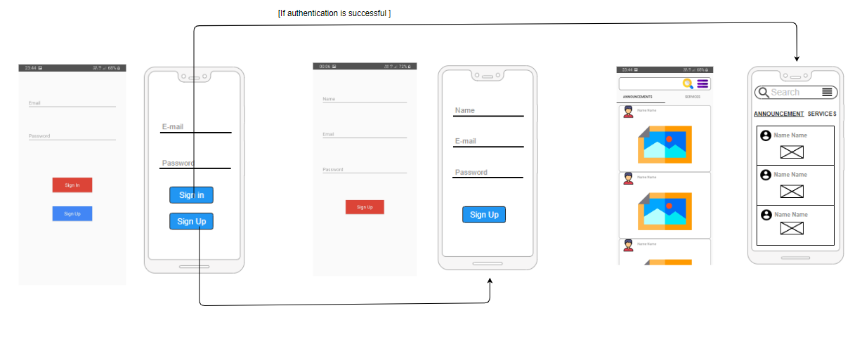

***User account control (log out)***

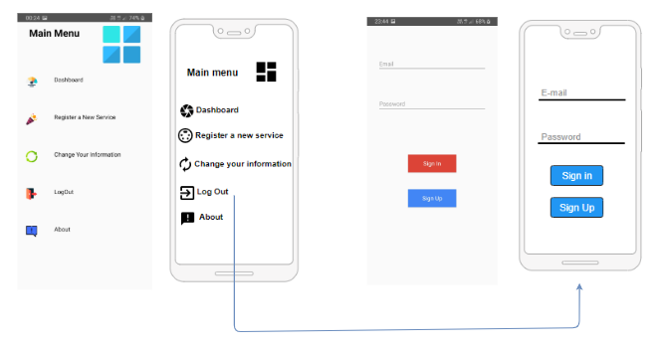

***Resource values***

*(strings.xml)*

<**string name="feedback_heading"**>Feedback</**string**>  
<**string name="feedback_rating"**>Rating</**string**>  
<**string name="feedback_review"**>Review</**string**>  
<**string name="feedback_and_ratings_heading"**>Feedback</**string**>  
<**string name="feedback_and_ratings_name"**>Name Name</**string**>  
<**string name="feedback_and_ratings_rating"**>x.x/5</**string**>  
<**string name="feedback_and_ratings_comment"**>comment comment comment comment comment comment comment comment comment comment comment comment comment comment comment comment comment</**string**>  
<**string name="home_tab_Announcements"**>Announcements</**string**>  
<**string name="home_tab_Services"**>Services</**string**>  
<**string name="login_email"**>Email</**string**>  
<**string name="login_password"**>Password</**string**>  
<**string name="login_sign_in"**>Sign In</**string**>  
<**string name="login_sign_up"**>Sign Up</**string**>  
<**string name="main_menu"**>Main Menu</**string**>  
<**string name="main_menu_dashboard"**>Dashboard</**string**>  
<**string name="main_menu_new_service"**>Register a New Service</**string**>  
<**string name="main_menu_change_info"**>Change Your Information</**string**>  
<**string name="main_menu_log_out"**>LogOut</**string**>  
<**string name="main_menu_about"**>About</**string**>

***CRUD operation plan***

A customer can give feedback and ratings relevant to the services given and also, they can view feedback and ratings of the other users who have used this application before so that the users can get an idea about the service providers and their services. If the feedback provider needs to update or delete the feedback which was given due to any reason, they can use the update and delete feedback options. Here, an assumption of the average rating count is made by the system. So, it is easy for the customers to choose the best service provider by referring the rating count.

**IT19011462 - Service details management and user account control (Update user details)**

***Update Service details***

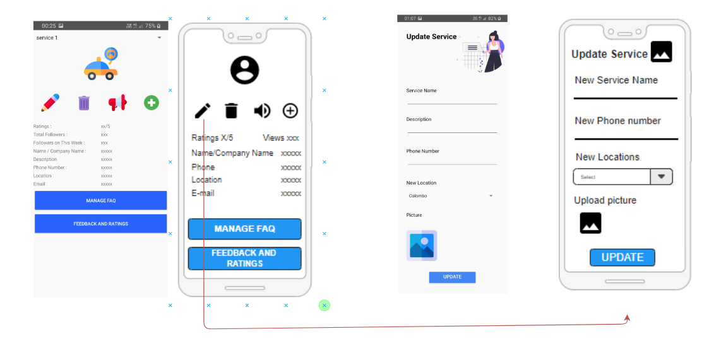

***Delete a service***

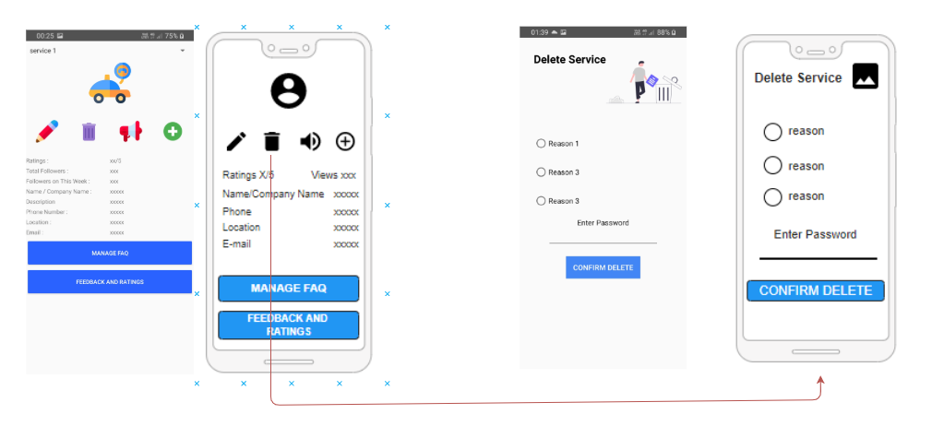

***Register a new Service***

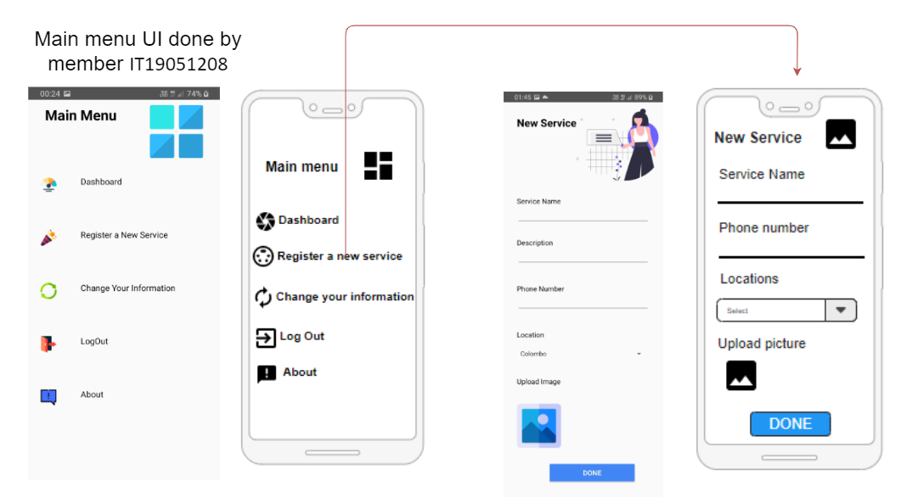

***Update user details***

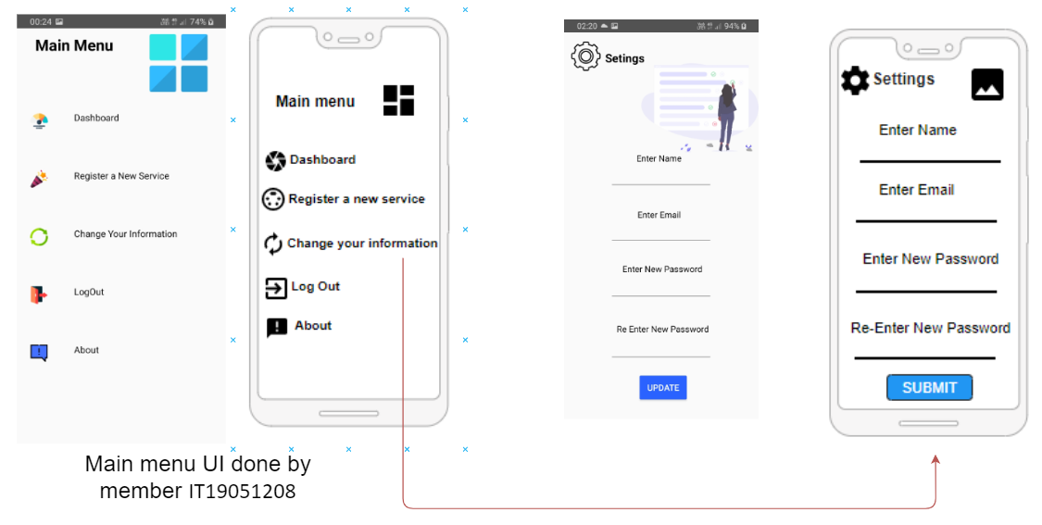

***Resource values***

*(strings.xml)*

<**string name="change_info_heading"**>Setings</**string**>  
<**string name="change_info_name"**>Enter Name</**string**>  
<**string name="change_info_email"**>Enter Email</**string**>  
<**string name="change_info_password"**>Enter New Password</**string**>  
<**string name="change_info_re_password"**>Re Enter New Password</**string**>  
<**string name="change_info_update_btn"**>Update</**string**>  
  
<**string-array name="location"**>  
 <**item**>Colombo</**item**>  
 <**item**>Badulla</**item**>  
 <**item**>Gampaha</**item**>  
 <**item**>Kandy</**item**>  
 <**item**>Anuradhapura</**item**>  
 <**item**>Galle</**item**>  
</**string-array**>  
  
  
<**string name="service_dashboard_ratings"**>Ratings :</**string**>  
<**string name="service_dashboard_total_followers"**>Total Followers :</**string**>  
<**string name="service_dashboard_followers_this_week"**>Followers on This Week :</**string**>  
<**string name="service_dashboard_name"**>Name / Company Name :</**string**>  
<**string name="service_dashboard_phone"**>Phone Number :</**string**>  
<**string name="service_dashboard_location"**>Location :</**string**>  
<**string name="service_dashboard_mail"**>Email :</**string**>  
<**string name="service_dashboard_faq_btn"**>manage faq</**string**>  
<**string name="service_dashboard_feedback_nd_ratings"**>Feedback and Ratings</**string**>  
<**string name="service_dashboard_data1"**>xx/5</**string**>  
<**string name="service_dashboard_data2"**>xxx</**string**>  
<**string name="service_dashboard_data3"**>xxxxx</**string**>  
<**string name="service_dashboard_description"**>Description</**string**>  
<**string name="update_service_heading"**>Update Service</**string**>  
<**string name="update_service_name"**>Service Name</**string**>  
<**string name="update_service_description"**>Description</**string**>  
<**string name="update_service_number"**>Phone Number</**string**>  
<**string name="update_service_upload_pic"**>Picture</**string**>  
<**string name="update_service_update_btn"**>update</**string**>

***CRUD operation plan***

A service provider can add the services that they provide. And the users can view the services. Sometimes a service provider may decide to provide some other service that he/she has studied other than the service that he is currently providing. So, in such instances, they can use update/delete options. A service provider can provide many services. So that a count of followers who follow a certain service is generated through the system.

**IT19021058 - Frequently asked question and service recommendation management**

***Add new FAQ***

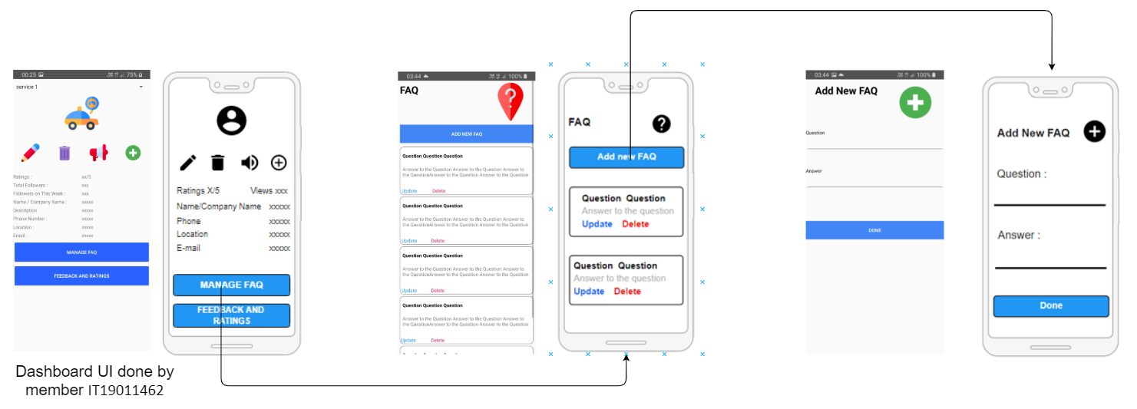

***Edit FAQ***

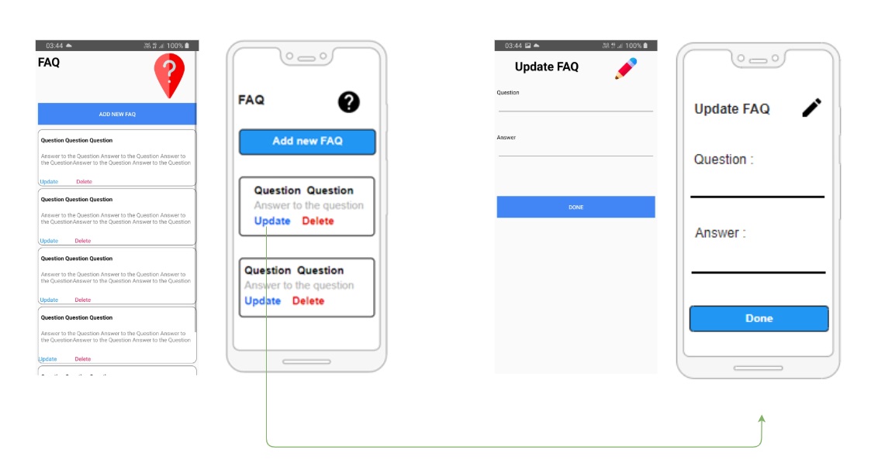

***Delete FAQ***

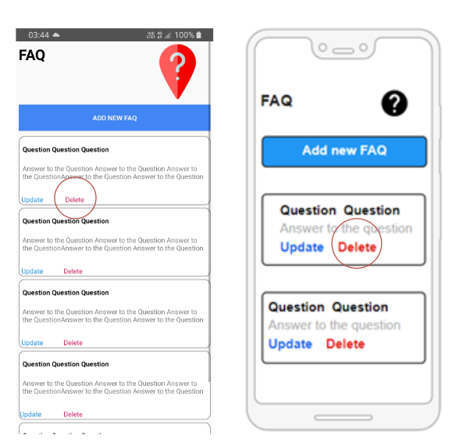

*\*when user clicks on delete button android system will prompt a dialog box to confirm action\**

***Service recommendations***

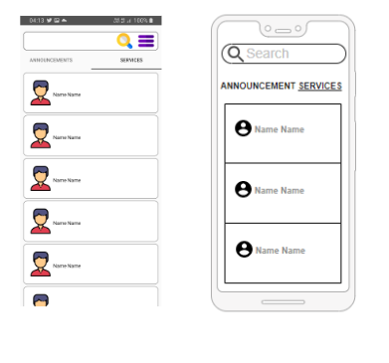

*\*recommendations are coming through an algorithm\**

***User reading FAQ on a service***

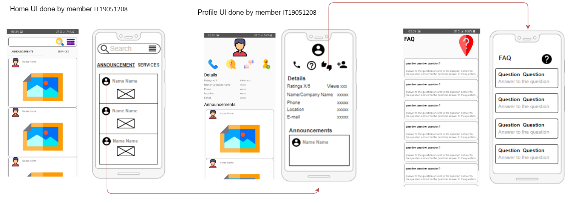

***Resource values***

*(strings.xml)*

<**string name="created_sample_question"**>Question Question Question</**string**>  
<**string name="FAQ_update_txt"**>Update</**string**>  
<**string name="FAQ_delete_txt"**>Delete</**string**>  
<**string name="FAQ_ans_txt"**>Answer to the Question Answer to the Question Answer to the QuestionAnswer to the Question Answer to the Question</**string**>  
<**string name="FAQ_heading_txt"**>FAQ</**string**><**string name="update_FAQ_heading_txt"**>Update FAQ</**string**>  
<**string name="update_FAQ_question"**>Question</**string**>  
<**string name="update_FAQ_answer"**>Answer</**string**>  
<**string name="update_FAQ_done"**>DONE</**string**>  
<**string name="see_faq_heading"**>FAQ</**string**>  
<**string name="see_faq_question"**>question question question ?</**string**>  
<**string name="see_faq_ans"**>answer to the question answer to the question answer to the question answer to the question answer to the question</**string**>  
<**string name="new_faq_heading"**>Add New FAQ</**string**>  
<**string name="about_heading"**>About</**string**>

***CRUD operation plan***

Adding relevant details to the FAQ session will make it easier for the customers to choose the best service provider for their needs. Therefore, the service providers can provide details and facts regarding the most frequently asked details and service recommendations through a FAQ session. They also can view, update, and delete the details when needed. A service provider can have many recommended services in his profile. Therefore, randomly selected services from all the services provided are displayed by using a certain algorithm.

**IT19044446 - Announcement management**

*Add new announcement*

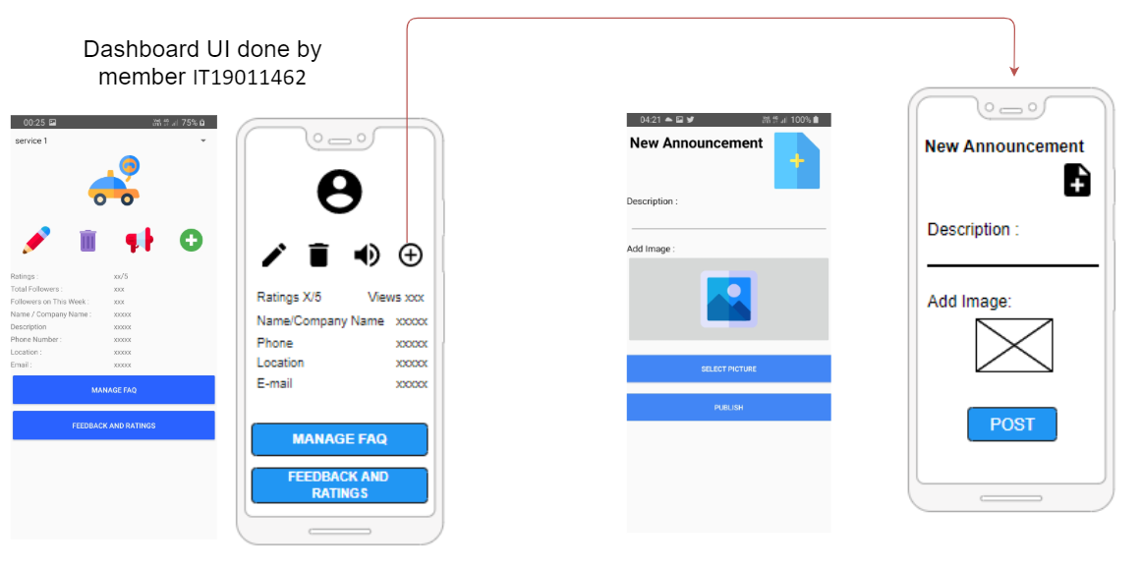

***Update announcement***

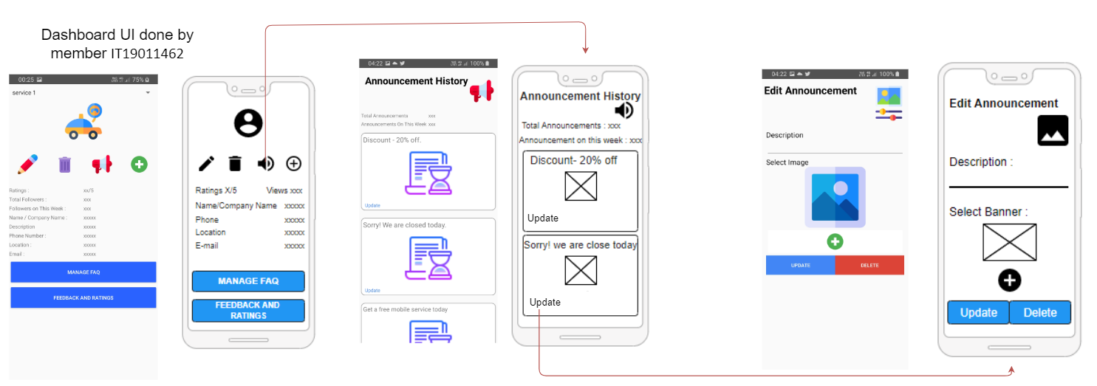

***Delete an announcement***

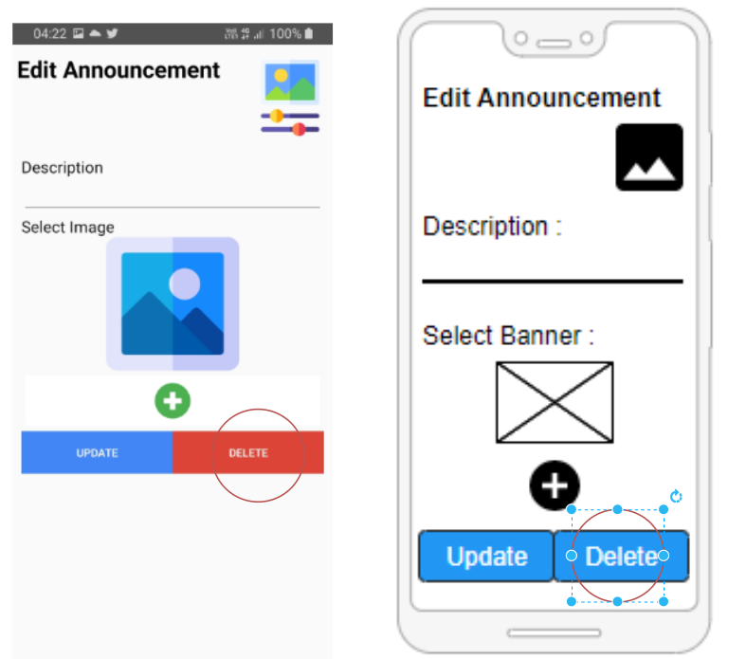

*\*when user clicks on delete button android system will prompt a dialog box to confirm the action\**

***Resource values***

*(strings.xml)*

<**string name="new_announcement_heading"**>New Announcement</**string**>  
<**string name="new_announcement_description"**>Description :</**string**>  
<**string name="new_announcement_add_image"**>Add Image :</**string**>  
<**string name="new_announcement_select_image"**>Select Picture</**string**>  
<**string name="new_announcement_post"**>Publish</**string**>  
<**string name="announcement_history_heading"**>Announcement History</**string**>  
<**string name="announcement_history_total"**>Total Announcements</**string**>  
<**string name="announcement_history_on_this_week"**>Announcements On This Week</**string**>  
<**string name="announcement_history_update"**>Update</**string**>  
<**string name="announcement_history_t1"**>Discount - 20% off.</**string**>  
<**string name="announcement_history_t2"**>Sorry! We are closed today.</**string**>  
<**string name="announcement_history_t3"**>Get a free mobile service today</**string**>  
<**string name="announcement_history_data"**>xxx</**string**>  
<**string name="edit_announcement_heading"**>Edit Announcement</**string**>  
<**string name="edit_announcement_description"**>Description</**string**>  
<**string name="edit_announcement_select_image"**>Select Image</**string**>  
<**string name="edit_announcement_update"**>update</**string**>  
<**string name="edit_announcement_delete"**>delete</**string**>

***CRUD operation plan***

A service provider can use the announcement category to convey very important messages to their customers such as giving discounts to certain services provided and in instances in which the service provider is not available on a specific day. They can add new announcements, view announcements, and update/delete announcements when needed. A service provider may make many announcements during a specific month. Therefore, the monthly announcement count is being calculated by the system.